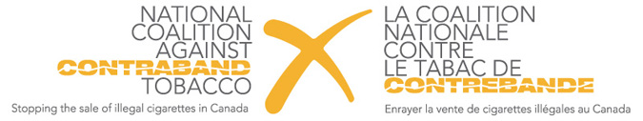
FOR IMMEDIATE RELEASE

Budget 2019 Lacks Clear Path to Address the Flourishing Trade of Contraband Tobacco in Ontario

April 11th, 2019, Queen’s Park (TORONTO) - Today, Gary Grant, the National Spokesperson for the National Coalition Against Contraband Tobacco (NCACT) partook in the Ontario Budget 2019 Lock-up. The budget, tabled by the Ontario Minister of Finance Vic Fedeli, lacked the necessary funding to address contraband tobacco in the province, despite the expressed actions laid out in the 2018 Fall Economic Statement.

Ontario has the unfortunate distinction of leading the country in both the production and the sale of contraband tobacco, with rates of over 30% throughout the province, soaring to rates as high as 65% in Northern communities. The previous government made minor adjustments throughout the years, yet contraband rates have remained consistently high over the past decade.

“Contraband tobacco continues to take away more than $750 million from provincial tax revenue,” said Mr. Grant, a 39-year veteran of the Toronto Police Service, and founder of Toronto Crime Stoppers. “This lost revenue is going directly to organized crime groups across the province – groups that traffic guns, drugs and humans.”

The NCACT was encouraged by the 2018 Fall Economic Statement, wherein the government signaled an increased focus on contraband tobacco. Namely, the statement laid out a general contraband strategy which included actions such as the conception of an awareness campaign in high contraband communities, as well as an increase in the number of members of the Contraband Tobacco Enforcement Team.

The 2019 budget was expected to further actions initiated in the FES based on the success of Quebec’s contraband tobacco strategy, which began in 2009 and subsequently saw a 50% decrease in illegal tobacco over just two years. In the last Quebec budget, the government announced that they have seen an increase in tax revenue of $186 million due to their contraband tobacco strategy, which includes allowing all police services to take part in contraband investigations, creating a funding mechanism for local and regional police services, and supporting their dedicated Contraband Tobacco Enforcement Team of 54 members.

“Contraband tobacco rates in Ontario could decrease to similar statistics should the Ontario Government decide to implement a Quebec-style strategy. This would increase provincial tax revenue, while simultaneously addressing organized crime, in turn creating a safer Ontario. We look forward to continuously working with the government to get the solution right.” concluded Mr. Grant.

-30-

The National Coalition Against Contraband Tobacco is a Canadian advocacy group formed by organizations and associations concerned about the growing danger of contraband cigarettes. NCACT members share the goals of working together to educate people and urge government to take quick action to stop this growing threat. More information about the Coalition can be found on our website, www.stopcontrabandtobacco.ca.

Media Contact:
Hilary Cole, NCACT Public Affairs
Telephone: 905-751-4022
Email: info@stopcontrabandtobacco.ca

